Question 3:

How did you create the filter? Did you get a good result, i.e. like the middle image of Figure 1? Why/why not? (Possibly there is a lot of white pixels – do not worry).
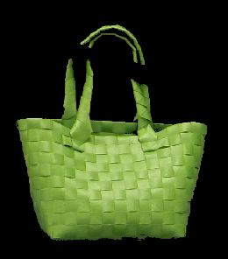
The following code gave a pixelated cut out of the green bag, but there are some clear missing pieces where different hues of green does not meet the strict thresholds.
First the workspace and command window are cleared.
Then the image is read and convert to a double so we can divide an image into RGB colours for more precise colour calculations.
A greenMask creates a mask for the pixels where green is the dominant colour or where the green channel is much larger then both red and blue channels ((G > R + 0.05) & (G > B + 0.05)), and above a brightness threshold(G<0.3).
GreenOnly first creates a black image and fills in with the values that now are either black or dominated by the colour green that the greenMask evaluated to be true(Green).
clc;
clear;

I = imread('img/bob.JPG');
I = im2double(I);
R = I(:,:,1);
G = I(:,:,2);
B = I(:,:,3);
greenMask = (G > 0.3) & (G > R + 0.05) & (G > B + 0.05);
GreenOnly = zeros(size(I));
GreenOnly(:,:,1) = R .* greenMask;
GreenOnly(:,:,2) = G .* greenMask;
GreenOnly(:,:,3) = B .* greenMask;

Suggest how to improve the result.
Change the values of the row “greenMask = (G > 0.4) & (G > R + 0.1) & (G > B + 0.1);
“. If we lower 0.4 and the margin for R + 0.1 and B + 0.1 the mask will be less strict with the exact match of dominant colour and could mask out the entire bag. But then also there is the risk that it will take other pixels who are not the bag. So, there will be a trade-off. A course of action to limit this trade-off could be to edit the original image. To first detect the bag and crop the image around the bag.

How do you create the green filter in this color space? Which parameter was the most important?
In the HSV colour space the primary parameter is Hue (representing the actual colour). Saturation and Value parameter control the amount of darkness and grey tones will be permitted in the selected range.
To create the green filter, I adjusted the colour wheel so it would only cover the green segment.

How does your filtered image compare to the previous RGB-based result?
It has a much smoother filter with the colours, leaving a less pixelated bag.

Change the color of the green bag to blue, similarly to the color changed (rightmost) image of Figure 1. How did you do this?
Convert from RGB to HSV with rgb2hsv. Then in the HSV the Hue channel was adjusted by adding 0.35 (approximately 126 degrees on the colour wheel) changing green to blue hue. Lastly the image was converted back to RGB with hsv2rgb.

- HSVPic = rgb2hsv(maskedRGBImage);
- HSVPic(:,:,1) = mod(HSVPic(:,:,1) + 0.35, 1);
- HueChange = hsv2rgb(HSVPic);

Show the resulting image

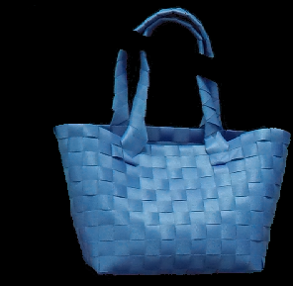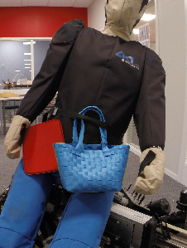

Question 4:

Convolution is associative, compare A=(I*s)*g and B=I*(s*g). Do they produce the same result?
Yes
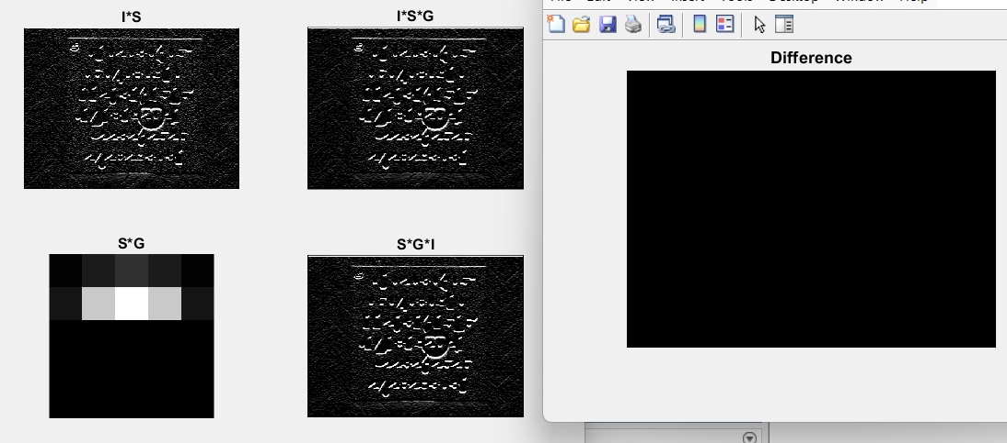
Max(max(diff) = 1.7764e-15

Which one is quicker and why? Use tic, toc. Note: As the image is small loop the operation to get a better time estimation.
A: Convolve the image with Sobel, then convolve with Gaussian.
B: Convolve Sobel and Gaussian, then convolve that with the image.
B is quicker because it first does a filter-filter convolution then filter-image convolution. And A has 2 image-filter convolution which are more costly. Since an image has a lot more elements than a filter. Examples can be img (512x512 = 262 144) and filters (3x3 = 9).

Question 5:

What was the result of your 4 depth estimations? What do you conclude from these with respect to measurement and distortion?
Pen1(difference 4mm) have a smaller change in depth estimation compared to pen2(difference 50mm). This occurs due to Barrel distortion, in short making straight lines seem curved, which shortens or/and extends measurements depending on the objects position on the image. And in that, affects the depth estimation who builds upon the measured length in the image. For both pen1 and pen2 the depth got lower after un distortion. This tells us that the distortion had enlarge the pen’s measured length in the image. Thus, an overestimation of depth.
